Predicting Heart Attack Risk Using Machine Learning
Background and Problems
Cardiovascular diseases (CVD), particularly heart attacks, are among the leading causes of death globally. Many individuals remain unaware of their underlying heart conditions until they become critical. Traditional diagnostic procedures can be time-consuming and expensive, often requiring complex clinical assessments and equipment. As a result, there is an urgent need for effective, scalable, and affordable predictive tools that can help in the early identification of at-risk individuals. Machine learning offers a powerful alternative to traditional screening, as it can leverage patterns in large datasets to provide risk predictions based on readily available health and lifestyle data.
The aim of this study is to build and evaluate an AI-based predictive model that can identify individuals at risk of heart attacks using commonly collected features such as demographics, lifestyle habits, and basic clinical measurements. This model could serve as a pre-diagnostic tool to prioritize individuals for further testing and preventive intervention.
Dataset Description
The dataset consists of 8,763 patient records, each annotated with 26 variables, including demographics, clinical features, and lifestyle information. The target variable indicates whether the patient is at risk of a heart attack (binary classification: 1 for risk, 0 for no risk).
Key features in the dataset:
- Demographic Information: Age, Sex, Income, Country, Continent, Hemisphere
- Clinical Variables: Cholesterol, Blood Pressure (Systolic/Diastolic), Heart Rate, BMI, Triglycerides
- Lifestyle Factors: Smoking, Alcohol Consumption, Exercise Hours, Sleep Hours, Diet, Sedentary Hours
- Medical History: Diabetes, Family History, Previous Heart Problems, Medication Use, Stress Level
- Other: Obesity, Physical Activity Days, Country & Region Metadata
Categorical variables were converted to numerical form, and missing values were handled appropriately. The dataset was split into 80% for training and 20% for testing.
Methodology
To develop an effective predictive system, several supervised machine learning algorithms were trained and compared using structured model evaluation techniques.
1. Logistic Regression
This statistical classification model estimates the probability of a binary outcome (e.g., risk or no risk of heart attack) based on input features. It calculates log-odds and uses the sigmoid function to map predictions to probabilities between 0 and 1.
2. Naive Bayes Classifier
This probabilistic classifier applies Bayes Theorem with the assumption that all input features are independent. It is computationally efficient and suitable for high-dimensional data. The model estimates the probability of each class based on the prior and likelihood distributions.
3. Decision Tree
A tree-based model that splits the dataset recursively based on attribute values to classify the target variable. Splitting is done using criteria like Gini Index or Information Gain, and the tree continues branching until leaf nodes represent classification outcomes.
4. Random Forest
An ensemble method consisting of multiple decision trees, where each tree is trained on a random subset of the dataset. The final prediction is made based on the majority vote from all trees. This technique improves robustness, reduces overfitting, and increases generalization performance.
5. AdaBoost
This boosting ensemble method combines multiple weak classifiers sequentially. Each new classifier focuses more on instances misclassified by previous models. We used decision trees as base learners and controlled their influence through assigned weights and a learning rate.
6. Bagging Classifier
Bagging (Bootstrap Aggregation) involves training multiple base models on different subsets of the dataset sampled with replacement. The final prediction is made by aggregating predictions from each model. Random Forest is a common form of bagging.
7. Evaluation Process
All models were evaluated using:
- Train-Test Split (80–20%)
- 5-Fold Cross Validation
Metrics evaluated included: Accuracy, Precision, Recall, F1-Score, and ROC-AUC.
Results and Evaluation
Six supervised machine learning models were evaluated on their ability to predict heart attack risk using a real-world dataset. Each model's performance was assessed using five standard classification metrics: Accuracy, Precision, Recall, F1-Score, and Area Under the ROC Curve (AUC).
Performance Metrics Table:
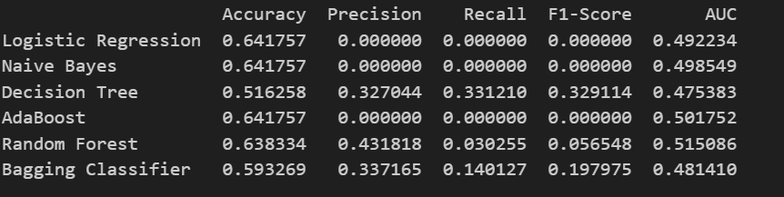
Model Accuracy Comparison Chart:
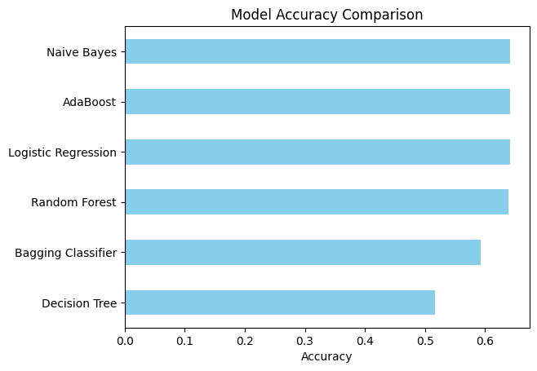
ROC curve
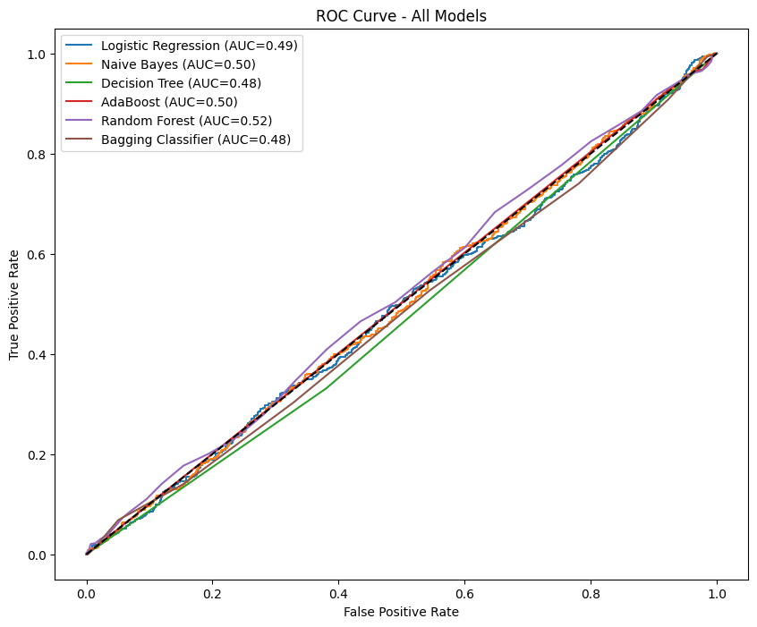

Analysis:
Among the six models tested, Random Forest showed the highest overall performance in terms of class separation capability, with an AUC score of 0.515, and the highest precision of 0.432. Although its recall (0.0326) was low, it was the only model that demonstrated a slight improvement in identifying true positives compared to others.
The Decision Tree and Bagging Classifier models demonstrated moderate recall (0.331 and 0.140 respectively) and better F1-scores than models like Logistic Regression and Naive Bayes, which entirely failed to detect positive cases (F1-score = 0.000).
Observations:
- Logistic Regression, Naive Bayes, and AdaBoost each achieved high accuracy (~64%) but completely failed to identify any positive heart attack risk cases, leading to zero values for precision, recall, and F1-score.
- Decision Tree achieved the highest recall (0.331), indicating better sensitivity to the positive class, but its overall accuracy and AUC were lower (0.516 and 0.475 respectively).
- Bagging Classifier also provided balanced results, with an F1-score of 0.198, indicating better handling of imbalanced data compared to baseline models.
- Random Forest yielded the most stable performance across metrics, achieving the best precision and AUC, making it the most effective classifier among the models tested in this study.
Feature Importance
To interpret the model’s predictions and understand the contribution of individual features to heart attack risk classification, SHAP (SHapley Additive exPlanations) analysis was applied. SHAP values measure the impact of each feature on the model’s output for every prediction, offering both global and local interpretability.
Top Predictive Features (SHAP Summary)
The SHAP summary plot below illustrates the most influential features across all patient records in the model. The horizontal axis shows the SHAP value, indicating how much each feature increases or decreases the predicted risk. The color gradient represents the feature value from low (blue) to high (red).
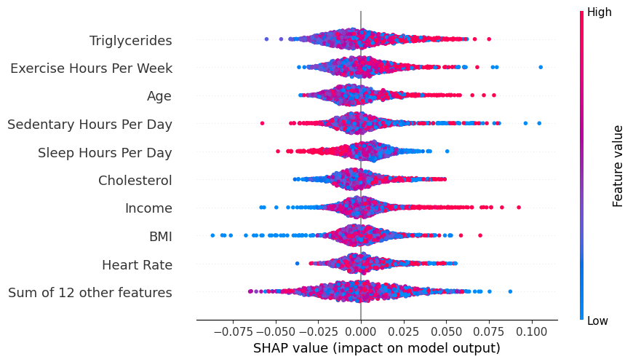

The SHAP summary plot above illustrates the top features influencing the model's prediction of heart attack risk. Triglycerides, exercise hours, age, and sedentary time were the most impactful variables. Higher triglycerides and lower exercise levels significantly increased predicted risk, while older age and longer inactivity also contributed to higher risk. Other important factors included sleep duration, cholesterol, BMI, and heart rate, with both clinical and lifestyle features playing key roles in the model’s output.
Conclusion
This study applied various supervised machine learning techniques to predict heart attack risk using a dataset containing clinical, demographic, and lifestyle-related features. After preprocessing and feature engineering, six models-Logistic Regression, Naive Bayes, Decision Tree, AdaBoost, Random Forest, and Bagging were developed and evaluated.
Among all models, Random Forest demonstrated the most balanced performance, achieving the highest precision and AUC, although recall remained low across all classifiers due to class imbalance. The model evaluation highlighted the need for improved sensitivity, potentially through resampling techniques or threshold adjustments.
To enhance interpretability, SHAP analysis was conducted, revealing that triglyceride levels, exercise hours, age, sedentary behavior, cholesterol, and BMI were the most influential features driving risk predictions. These insights align with established medical knowledge, validating the reliability of the model's predictions.
Overall, the machine learning approach shows promising potential as a decision-support tool for early heart attack risk screening. Future work should focus on improving class sensitivity and integrating more diverse clinical variables to strengthen prediction accuracy and real-world applicability.
References
- Hossain, S., Hasan, M. K., Faruk, M. O., Aktar, N., Hossain, R., & Hossain, K. (2024). Machine learning approach for predicting cardiovascular disease in Bangladesh: evidence from a cross-sectional study in 2023. BMC Cardiovascular Disorders, 24(214). https://doi.org/10.1186/s12872-024-03883-2.
- Rojek, I., Kotlarz, P., Kozielski, M., Jagodziński, M., & Królikowski, Z. (2024). Development of AI-Based Prediction of Heart Attack Risk as an Element of Preventive Medicine. Electronics, 13(2), 272. https://doi.org/10.3390/electronics13020272.
- Lundberg, S. M., & Lee, S.-I. (2017). A unified approach to interpreting model predictions. Advances in Neural Information Processing Systems, 30. https://proceedings.neurips.cc/paper_files/paper/2017/file/8a20a8621978632d76c43dfd28b67767-Paper.pdf
- Freund, Y., & Schapire, R. E. (1997). A decision-theoretic generalization of on-line learning and an application to boosting. Journal of Computer and System Sciences, 55(1), 119–139.
- Khosla, M., Cao, Y., Lin, Z. Q., Chiu, B., Hu, P., & Wong, A. (2019). Machine learning for cardiovascular risk prediction: A review of the current literature. Current Atherosclerosis Reports, 21(6), 1–10.
Data Availability: Kaggle dataset https://www.kaggle.com/datasets/iamsouravbanerjee/heart-attack-prediction-dataset.

NOTE:
- The results initially included in the presentation were based on an early run of the models and were meant to be temporary. After re-running the analysis with improved preprocessing and finalized model settings, the performance metrics changed. The results presented in this report are updated and more accurate reflections of the model's performance.
- Parts of this report were prepared with the assistance of AI tools for structuring content, explaining methods, and interpreting results. Grammarly was also used to ensure clarity, grammar, and readability throughout the document.

Github link- https://github.com/DivyaReddy262/COMP-ANALY-HIGH-TP-BIOMED-DATA/tree/PROJECT

